Retail Sales, Product & Customer Insights Using SQL

Project Overview
This project focuses on analyzing retail sales performance, customer spending behavior, and product-level insights using SQL. The goal is to build a complete analytics workflow—from data cleaning and aggregation to segmentation and KPI calculation.

Business Objectives
1. Analyze time-based sales trends.
2. Evaluate product performance (Avg vs YoY).
3. Determine category contribution.
4. Segment customers (VIP, Regular, New).
5. Generate customer-level KPIs and behavior insights.

Change Over Time Analysis
Select DATETRUNC(Month, order_date) Order_date,
Sum(sales_amount) As Total_Sales,
Count(distinct Customer_key) as Total_customer,
SUM(quantity) AS Total_Quantity
From gold.fact_sales
Where order_date is not null
Group by DATETRUNC(Month, order_date)
order by DATETRUNC(Month, order_date)
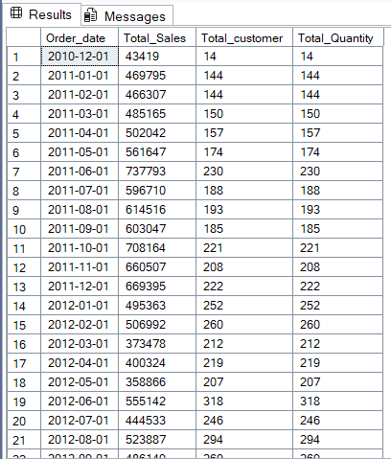

Cumulative Analysis
Calculate total sales Per Month and the running total of sales overtime

Select Order_Date,
Total_sales,
Sum(Total_sales) Over(order by order_date) as Running_Total,
AVG(Avg_price) Over (order by Order_date) As Moving_Average
From

(
Select DATETRUNC(Year,order_date) as Order_Date,
SUM(sales_amount) as Total_sales,
AVG(price) As AVG_Price
From gold.fact_sales
Where Datetrunc(Year,Order_date) is not null
Group by Datetrunc(Year,Order_date)
)t
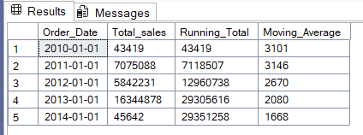

Performance Analysis
Analyze the Yearly Performance of Products by comparing Each products sale to both its average sales performance and the Previous Years sales

With yearly_Prdct_sales AS(

Select Year(F.order_date) AS Order_year,
P.product_name,
Sum(f.sales_amount) as Current_sales
From gold.fact_sales f
LEFT Join gold.dim_products p
on f.product_key=p.product_key
where order_date is not null
Group by Year(F.order_date),P.product_name
)

Select Order_year,
product_name,
Current_sales,
AVG(Current_sales) Over(partition by pRODUCT_NAME) AS Avg_sales,
Current_sales-AVG(Current_sales) Over(partition by pRODUCT_NAME) AS Difference,
Case When Current_sales-AVG(Current_sales) Over(partition by pRODUCT_NAME)>0 Then 'Above Average'
When Current_sales-AVG(Current_sales) Over(partition by pRODUCT_NAME)<0 Then 'Below Average'
Else 'Average'
End AVG_Change,
LAG(Current_sales) Over(Partition by Product_name Order by Order_year ) AS Prev_Year_Sales,
Current_sales-LAG(Current_sales) Over(Partition by Product_name Order by Order_year ) AS Difference_PY,
Case When Current_sales-LAG(Current_sales) Over(Partition by Product_name Order by Order_year )>0 Then 'Increase'
When Current_sales-LAG(Current_sales) Over(Partition by Product_name Order by Order_year )<0 Then 'Decrease'
Else 'No Change'
End Change
From yearly_Prdct_sales
order by product_name,order_year
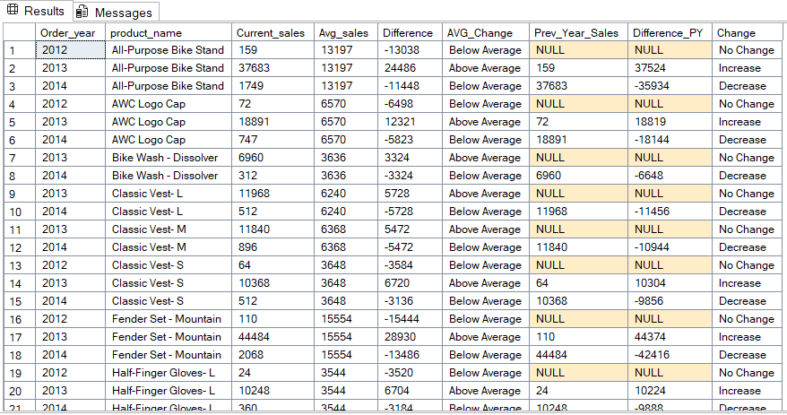
Part To Whole Analysis
Which Category Contribute most to the overall sales

Select category,
Count(customer_key) As Customers ,
Sum(sales_amount) as Total_Sales,
Sum(Sum(sales_amount)) Over() as Overall_Sales,
Concat(Round((CAST(Sum(sales_amount)AS Float)/Sum(Sum(sales_amount)) Over()) *100,2),'%') AS Percentage_of_TotalSales
From gold.fact_sales f
Left Join gold.dim_products p
On p.product_key=f.product_key
Group by category
Order by Sum(sales_amount) Desc
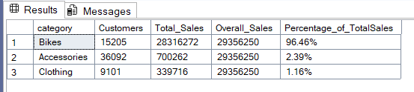
Data Segmentation
1.Segment products into cost ranges and count how many products fall into each segment

with Product_segment As
(Select product_key, product_name, category, cost,
Case When cost<100 Then 'Below 100'
When cost Between 100 And 500 Then '100-500'
When cost Between 500 And 1000 Then '500-1000'
Else 'Above 1000'
End Cost_Range
From gold.dim_products
)

select category, Cost_Range,Count(*) as Total_Products
From Product_segment
Where category is not null
Group by category,Cost_Range
Order by category;
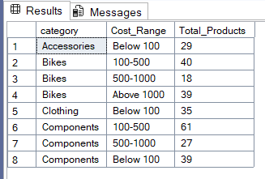

2 Group customers into three segments based on their spending behavior:

- VIP Customers-Customer has at least 12 months of activity/history AND total spending is more than 5,000

- Regular Customers-Customer has at least 12 months of activity/history AND total spending is 5,000 or less

- New Customers-Customer's lifespan is less than 12 months

Goal:
Find the total number of customers in each segment.

With Customer_spendings AS(
Select c.customer_key,
Sum(f.sales_amount) Total_spent,
Min(order_date) First_order,
Max(Order_Date) Last_order,
DATEDIFF(Month,Min(order_date),Max(Order_Date)) As LifeSpan
from gold.dim_customers c
left Join gold.fact_sales f
on f.customer_key=c.customer_key

Group by c.customer_key
)

Select Customer_Segment,Count(customer_segment) Total_Customers
From
(Select customer_key,
Case When lifespan>=12 and total_Spent > 5000 Then 'VIP'
When lifespan>=12 and total_Spent<= 5000 Then 'Regular'
ELse 'New Customer'
End Customer_Segment

From Customer_spendings)t
Group by Customer_Segment
order by Total_Customers DESC
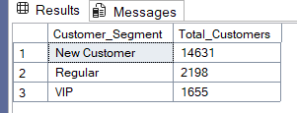

Customer Report
Purpose: This report consolidates key customer metrics and behaviors.

Highlights:

- Gathers essential fields such as names, ages, and transaction details.
- Segments customers into categories (VIP, Regular, New) and age groups.
- Aggregates customer-level metrics:
  - total orders
  - total sales
  - total quantity purchased
  - total products
  - lifespan (in months)
- Calculates valuable KPIs:
  - recency (months since last order)
  - average order value
  - average monthly spend

Create View gold.report_customer AS
with base_query as
(Select
f.order_number,
f.product_key,
f.order_date,
f.sales_amount,
f.quantity,
c.customer_key,
c.customer_number,
CONCAT(c.first_name,' ',c.last_name) AS Customer_Name,
Datediff(year,c.birthdate,GETDATE()) Age
From gold.fact_sales f
LEft join gold.dim_customers c
on c.customer_key=f.customer_key
Where order_date is not null)

,customer_aggregations as(
Select customer_key,
customer_number,
Customer_Name,
Age,
Count(distinct order_number) as Total_order,
Sum(sales_amount) as Total_Sales,
Sum(Quantity) as Total_Quantity,
Count(distinct product_key) as Total_Products,
MAx(Order_date) as Last_order_date,
DATEDIFF(Month,Min(order_date),Max(Order_Date)) As LifeSpan

From base_query
Group by customer_key,
customer_number,
Customer_Name,
Age
)

Select
customer_key,
customer_number,
Customer_Name,
Age,Case When Age <20 Then 'Under 20'
When Age Between 20 And 29 Then '20-29'
When Age Between 30 And 39 Then '30-39'
When Age Between 40 And 49 Then '40-49'
ELse '50 And ABOVE'
End Age_Group,

Case When lifespan>=12 and Total_Sales > 5000 Then 'VIP'
When lifespan>=12 and Total_Sales<= 5000 Then 'Regular'
ELse 'New Customer'
End Customer_Segment,

DATEDIFF(month,last_order_date,Getdate()) as Recency,
Total_order,
Total_Sales,
Total_Quantity,
Total_Products,
LifeSpan,
Case when Total_sales=0 then 0
Else Total_Sales/Total_order
End as AVG_order_value,

Case when Lifespan=0 then total_sales
Else Total_Sales/Lifespan
End as AVG_Monthly_Spent

From customer_aggregations 